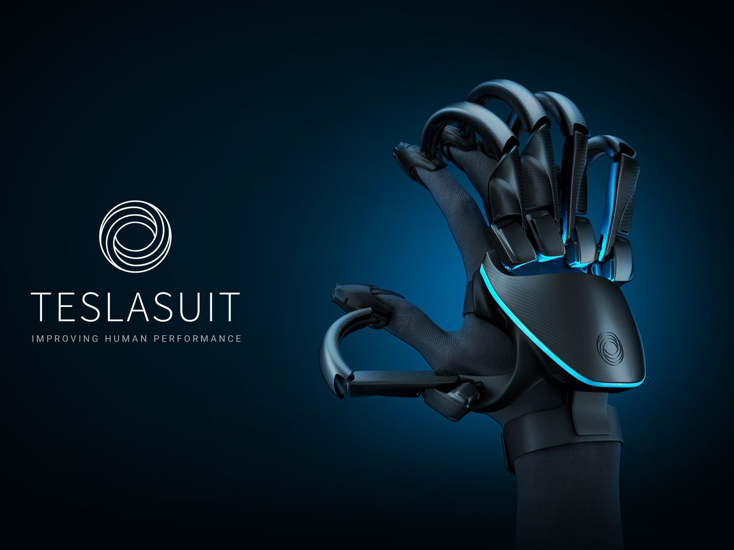Aleksandrs Lukjanovs (M00674847)

Individual Project CST3990

**Haptic Glove Project**

**Introduction**

Haptic gloves are not a new concept while not well know they have been in development as far back as 1977. They aim to improve over a traditional controller by offering improved immersion.

- Oculus Quest Controllers

These controllers are an industry standard.

Main notable features of these controllers are:

1. Very sensitive buttons that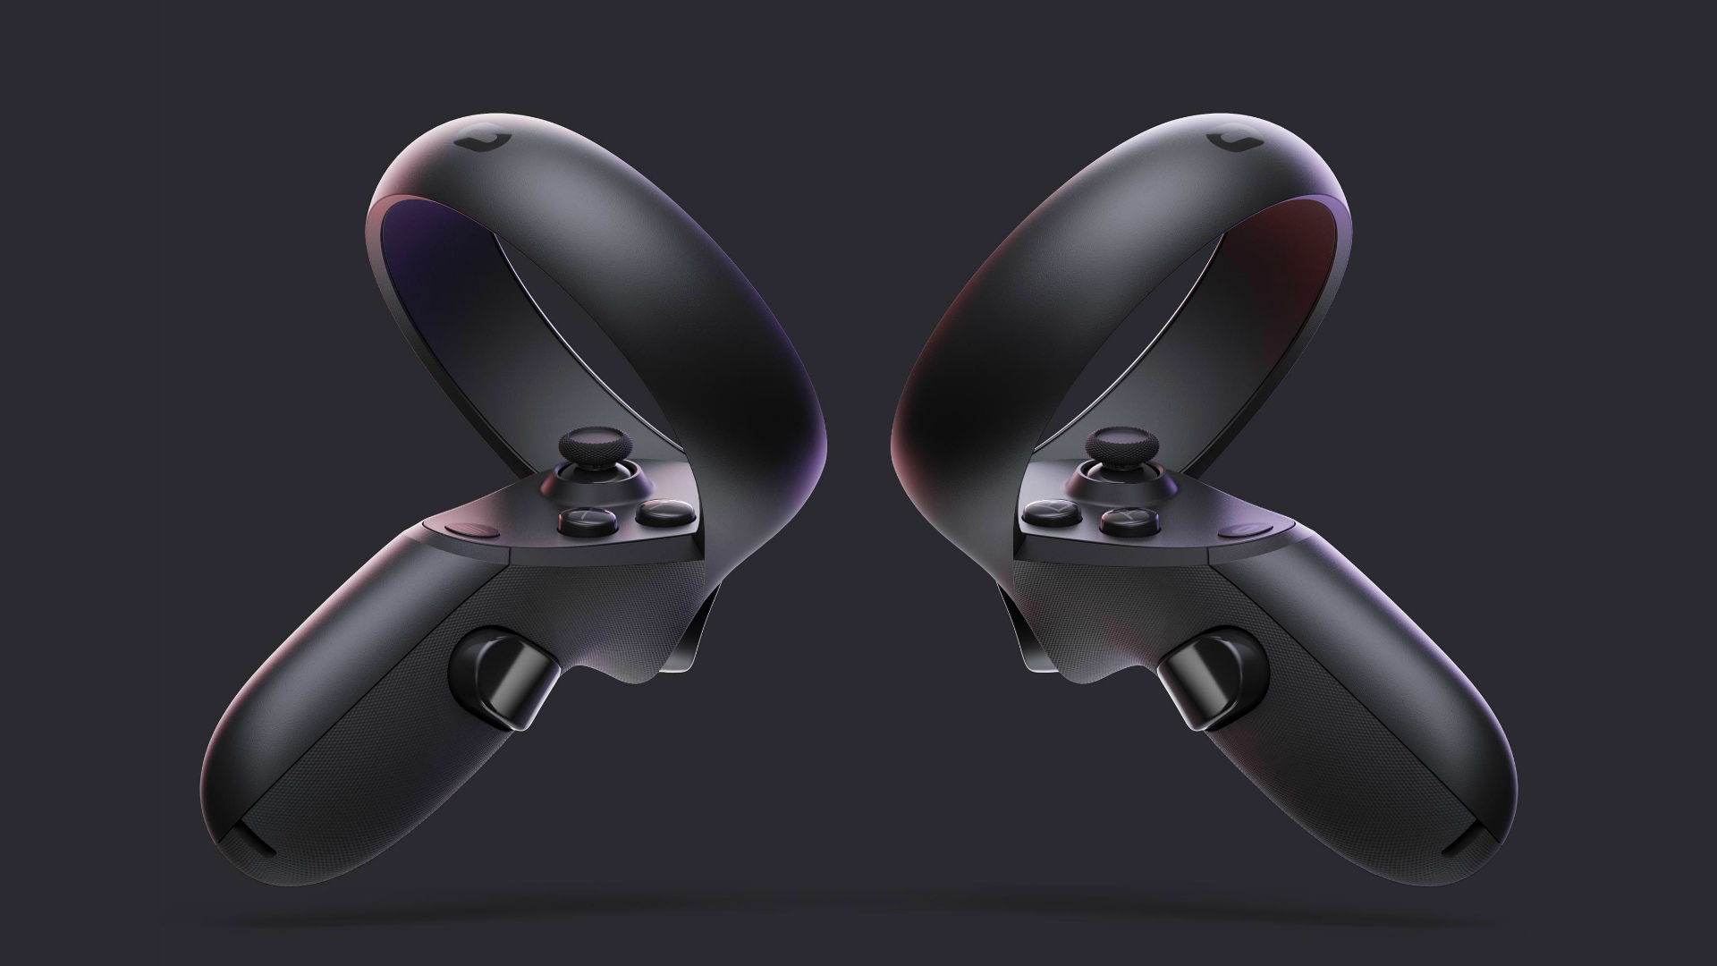 with even the slightest application of weight on the buttons will accordingly position your virtual fingers in the virtual environment.

2. The controllers have gyroscopes to tell in which orientation the controllers are positioned.

3. The controllers have motion sensors which allow the headset to determine when the controllers are moving. This allows the headset to predict the position better even if the controllers are not in the headsets view (which is the main tracking method).

4. Besides aforementioned features the controllers have joysticks.

My projects aim is to improve on the oculus quest controller design and create a haptic glove which will offer resistance for your fingers, improved feeling of sensation of touch, and improved tracking. All to allow you to further be immersed in VR.

**Objectives:**

- Create an exoskeleton which is able to prevent finger movement to simulate collision of your fingers in real life with an object improving immersion over an oculus quest controller.

- Use micro motors and controlled precise electro shocks to simulate sensation of touch and improve sensation accuracy over just a single vibrating motor in the oculus quest controller.

- Improve hand tracking so your hand can be more accurately represented in the 3D VR space compared to oculus quest controllers sensitive buttons.

- Investigate methods of cost reduction in the production environment.

**Deliverables:**

- Project Proposal

- Literature Review/ Progress Report

- Haptic Glove

- Testing Environment (Interactive game for the glove.)

- Final Report and Evaluation

**Approach**

**Creating the Test Environment**

I will use the unreal engine with it’s built in VR integration. The VR Integration implements all the necessary modules and settings needed for a basic VR game and is mainly intended for controllers.

I will adapt the VR integration for the use with the haptic glove. I will create a virtual object in a shape of a hand and assign it as my controller which the player can move. I will then animate the fingers which will interpret the positions provided by the potentiometers in the haptic glove skeleton to accordingly position the fingers in game. The fingers will have a sphere object on each finger tip and 12 more lower throughout the rest of the hand which correspond to a vibrator motor to be activated depending on which sphere is colliding with an object. The intensity of said motors will depend on how far inside the sphere the object you touch will travel.

The fingertips and the palm area of the controller object have collision which I will need to prevent the fingers from going inside the object. With solid collision I will need to rig the game hands to show me angles In between the finger joints and I will use those angles to decide weather to activate servos that will press down on the cables that will stop your finger movement.

**Testing**

Testing will be conducted in the university where I will find 100 volunteers for my focus group that will help me find out if I had achieved my objectives.

While testing the volunteers will play an exploration game where they will grab and manipulate various objects fully testing the capabilities of the glove. The volunteers will use both the controllers and then the gloves to complete tasks and will be asked questions after to compare and gather data.

The goal of the test is to establish if I have achieved my aforementioned objectives.

*- “Create an exoskeleton which is able to prevent finger movement to simulate collision of your fingers in real life with an object improving immersion over an oculus quest controller.”*

To test this I will task the volunteers with grabbing various objects with a standart oculus quest controller and move them around. Then the volunteers will switch to the haptic glove which will prevent finger movement when grabbing. Volunteers will be asked if the gloves function to stop fingers thereby simulating collision is more immersive than the oculus controller. Answer to be given is ‘Yes’ or ‘No’.

*- “Use micro motors and controlled precise electro shocks to simulate sensation of touch and improve sensation accuracy over just a single vibrating motor in the oculus quest controller.”*

To test this objective just as before the test will involve the volunteers grabbing objects with oculus controllers first and then with the haptic glove. Volunteers will be just touching objects with each individual finger to see if the motors respond accurately. I will also have the volunteers try to squeeze a little bit despite the fingers stopping which should cause the motors to increase in intensity.

I will also let the user close their eyes and look for the object with their sensors only to test accuracy and also I will have them try to determine what object it is with their eyes closed. Volunteers will be asked if the gloves increased amount of motors and the addition of shock technology is more accurate in transmitting sensation of touch compared to the oculus controller. Answer to be given is ‘Yes’ or ‘No’.

*- “Improve hand tracking so your hand can be more accurately represented in the 3D VR space compared to oculus quest controllers sensitive buttons.”*

To test this the volunteers will use a virtual keyboard against a standard keyboard and the oculus controllers to do a typing test. The higher score will show accuracy in numerical form. The previous tests should also give the users more of an accurate feel if they feel like their hands are more accurately represented. Also, volunteers will be asked if the gloves finger tracking technology is more immersive than oculus quest controllers. Answer to be given is ‘Yes’ or ‘No’.

*- “ Investigate methods of cost reduction in the production environment.”*

I would name the cost of the parts and labour involved in assembling the device at the end of the test and then, provide others haptic glove designs but from official companies like:

- Manus Prime X Haptic VR – 3D = £ 3403

- HI5 VR GLOVE = £744

Given all of the gloves including the haptic glove I have create and its price would they purchase my glove over the others? Answer to be given is ‘Yes’ or ‘No’.

**Milestones**

**13 Nov 2021 - 7 Jan 2022 = Research**

1. Research modelling software and tutorials that would allow me to produce the exo skeletons. 13 Nov 2021 - 17 Nov 2021

2. Make exoskeleton sketches. 17 Nov 2021 - 25 Nov 2021

3. Research different materials and 3D printing. 25 Nov 2021 - 30 Nov 2021

4. Research electrical components. 25 Nov 2021 - 30 Nov 2021

5. Create a circuit layout and additional sketches. 30 Nov 2021 - 6 Dec 2021

6. Research unreal engine tutorials and articles for VR rigging/ c# programming. 6 Dec 2021 - 17 Dec 2021

7. VR world design ideas. 17 Dec 2021 - 19 Dec 2021

8. Write literature review. 19 Dec 2021 - 7 Jan 2022

**8 Jan 2022 - 31 March 2022 = Produce Product, Test, Report**

1. Create first exoskeleton model. 8 Jan 2022 - 15 Jan 2022

2. Test electronics fit. 15 Jan 2022 - 19 Jan 2022

3. Design circuit layout and connections. 19 Jan 2022 - 24 Jan

4. Edit Model / Print test exo model. 20 Jan 2022 - 31 Jan 2022

5. Apply parts onto the exo model/program. 1 Feb 2022 - 11 Feb 2022

6. Test eco model and electronic component basic functionality. 11 Feb 2022 - 13 Feb 2022

7. Adjust exo design. 14 Feb 2022 - 16 Feb 2022

8. 3D print new design. 16 Feb 2022 - 20 Feb 2022

9. Apply electronic components/program. 21 Feb 2022 - 27 Feb 2022

10. Test 28 Feb

11. Final adjustments. 1 Mar 2022 - 6 Mar 2022

12. Create a test world in unreal and rig it for basic VR. 7 Mar 2022 - 9 Mar 2022

13. Connect the world to the glove. 10 Mar 2022 - 13 Mar 2022

14. Create the test environment. 14 Mar 2022- 20 Mar 2022

15. Testing with focus group to meet objectives. 21 Mar 2022 - 23 Mar 2022

16. Report 23 Mar 2022 - 31 Mar 2022

**Resources Needed:**

The main resources needed will vary however most definitive things needed would be the following:

- Access to 3D printer.

- Arduino

- Motors + Micro Motors

- Wire

- Aluminium Pads

- Glove

**Data Resources**:

- Papers:

1. F. Kato, Y. Inoue and S. Tachi, "Haptic Display Glove Capable of Force/Vibration/Temperature," 2019 IEEE International Symposium on Measurement and Control in Robotics (ISMCR), 2019, pp. D2-2-1-D2-2-5, doi: 10.1109/ISMCR47492.2019.8955735.

2. D. Shor et al., "Designing Haptics: Comparing Two Virtual Reality Gloves with Respect to Realism, Performance and Comfort," 2018 IEEE International Symposium on Mixed and Augmented Reality Adjunct (ISMAR-Adjunct), 2018, pp. 318-323, doi: 10.1109/ISMAR-Adjunct.2018.00095.

3.M. Hosseini, A. Sengül, Y. Pane, J. De Schutter and H. Bruyninck, "ExoTen-Glove: A Force-Feedback Haptic Glove Based on Twisted String Actuation System," 2018 27th IEEE International Symposium on Robot and Human Interactive Communication (RO-MAN), 2018, pp. 320-327, doi: 10.1109/ROMAN.2018.8525637.

4. T. K. Moriyama, A. Nishi, R. Sakuragi, T. Nakamura and H. Kajimoto, "Development of a wearable haptic device that presents haptics sensation of the finger pad to the forearm," 2018 IEEE Haptics Symposium (HAPTICS), 2018, pp. 180-185, doi: 10.1109/HAPTICS.2018.8357173.

5. Z. MA and P. Ben-Tzvi, "RML Glove—An Exoskeleton Glove Mechanism With Haptics Feedback," in IEEE/ASME Transactions on Mechatronics, vol. 20, no. 2, pp. 641-652, April 2015, doi: 10.1109/TMECH.2014.2305842.

6. S. Thomas and A. Devi, "Design and implementation of unmanned ground vehicle (UGV) for surveillance and bomb detection using haptic arm technology," 2017 International Conference on Innovations in Green Energy and Healthcare Technologies (IGEHT), 2017, pp. 1-5, doi: 10.1109/IGEHT.2017.8094106.

- Youtube: Has plenty of videos of DIY projects.

- Reddit: Plenty of posts about VR controllers.

- General Google Research: Millions of similar controller posts.